**Autism VR Demo Detail Description**

1. Show tittle “Daily Living” as a header
2. In the category “Daily Living”, there are some topics, player can use controller to select the topic. It should look like the image below:

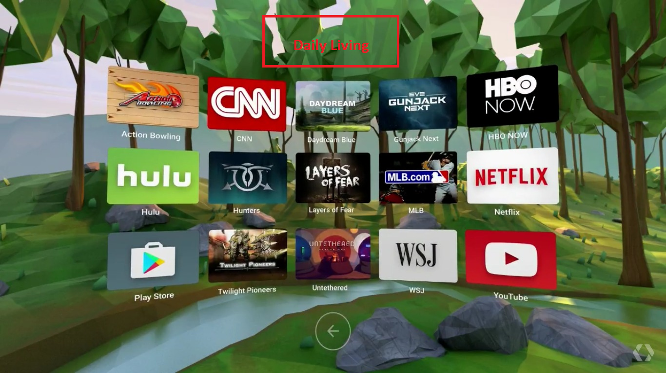

* Take a shower
* Brush the teeth
* Use the restroom
* Have a breakfast
* Buy foods
* Wash face
* Read a book
* Clean a floor
* Play with a dog

1. For now, player can only select “Taking shower”, others are static UI, when player select them, it should show only a white space.
2. For “Taking shower”, there are 16 steps:
   1. Close bath room door

* Show the text guide “Close the bathroom door” in front of the door
* Highlight the door locker so that player know it is clickable/selectable
* Player clicks/selects the locker to close the door
* Door animation
* Show the text guide “Well done!”
* Increase 1 point
  1. Place the clear clothes on a dry area
* Hide the previous text guide
* Show the text guide “Place the clear clothes on a dry area”
* Highlight the dry area so that player know it is clickable
* Player clicks on the dry area to put the clean clothes there
* Show the clean clothes after player click there
* Show the text guide “Good job!”
* Increase 1 point
  1. Take off your clothes and place it on a dry area
* Hide the previous text guide
* Show the text guide “Take off your clothes and place it on a dry area”
* Highlight the dry area so that player know it is clickable
* Player clicks on the dry area
* Show animation “take off clothes” and put it on the dry area
* Show the text guide “Perfect! You have done it.”
* Increase 1 point
  1. Open shower curtain/ shower door and Close it when is inside
* Hide the previous text guide
* Show the text guide “Open shower door”
* Highlight the door so that player know it is clickable
* Player clicks on the door to open it
* Show door animation
* Show the text guide “Close the shower door”
* Highlight the door so that player know it is clickable
* Player clicks on the door to close it
* Show door animation
* Show text guide “Good job!”
* Increase 1 point
  1. Turn on hot/cold water
* Hide the previous text guide
* Show the text guide “Turn on water, Red is hot water, Blue is cold water”
* Highlight the shower tab controller so that user know it is clickable
* Player click on the button to turn on water
* Water animation
* Show text guide “Great! Now test the water temperature”
* Increase 1 point
  1. Test water temperature
* Hide the previous text guide
* Show the text guide “Use your hand to test the water temperature”
* Player puts his hand (controller) into the water/shower area
* If in step 5.5, player turn on hot water, show text guide “The water is hot, please turn on cold water”
* If in step 5.5, player turn on cold water, show text guide “The water is fine, go ahead”
* Increase 1 point
  1. Taking a shower (wet head and body)
* Hide the previous text guide
* Show text guide “Step into the shower area”
* Highlight the shower area, under the shower so that player know it is clickable
* Player clicks on the area
* Show the character under the shower
* Show text guide “Great! Stay for 1 minute, wet your head and body”
* Increase 1 point
  1. Put shampoo in hand
* Hide the previous text guide
* Show text guide “Put shampoo in your hand”
* Highlight the shampoo so that player know it is clickable
* Player clicks on the shampoo
* Show animation player is taking shampoo and putting it into hand
* Increase 1 point
  1. Wash my hair
* Hide the previous text guide
* Show the text guide “Put shampoo on your hair”
* Highlight the hair area
* Player click on the hair area
* Show animation player is washing hair with shampoo
* Increase 1 point
  1. Rinse my hair
* Hide the previous text guide
* Show the text guide “Rinse your hair”
* Highlight the area below the shower
* Player click that area
* Show animation character walk into that area
* Show text guide “Great! Your hair is clean now”
* Increase 1 point
  1. Put shower foam on hand
* Hide previous text guide
* Show the text guide “Put shower foam on hand”
* Highlight the shampoo
* Player clicks on the shampoo
* Show animation player is taking shampoo and putting it into hand
* Increase 1 point
  1. Wash my body
* Hide previous text guide
* Show text guide “Wash your body with shampoo foam”
* Highlight body area
* Player clicks on the body area
* Show animation player is washing body with shampoo
* Increase 1 point
  1. Rinse my body
* Hide the previous text guide
* Show the text guide “Rinse your body”
* Highlight the area below the shower
* Player click that area
* Show animation character walk into that area
* Show text guide “Great! Your body is clean now”
* Increase 1 point
  1. Turn off the water
* Hide the previous text guide
* Show text guide “Turn off the water”
* Highlight the button
* Player clicks on the button
* Show text guide “Perfect! Almost done.”
* Increase 1 point
  1. Dry off my body and hair with a tower
* Character walk to the dry area
* Show text guide “Dry off your body and hair with a tower”
* Highlight the tower
* Player clicks on the tower
* Show animation player is using the tower to dry off hair and body
* Show text guide “Wonderful! Only one last step.”
* Increase 1 point
  1. Put on my clean clothes
* Show text guide “Put on your clean clothes”
* Highlight the clean clothes
* Player clicks the clean clothes
* Show animation player is wearing the clean clothes
* Increase 1 point
* Show text guide “You are wonderful! You have done all the steps.”
  1. DONE

1. Player need to complete all the steps in a topic to process to next topic. For now, we only have 1 topic which is “Take a shower”.
2. There is text guide box for each step the player need to do, player will follow the guide to complete all the steps. The text guide is a textbox with an arrow to attract player attention.

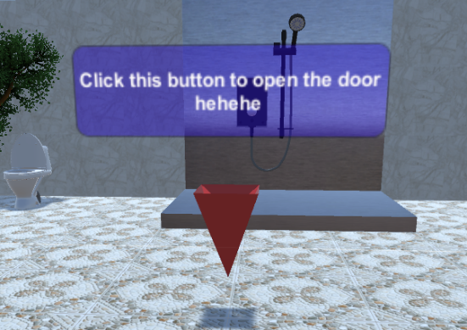

1. After player completed the topic, show it as completed with some starts as the result. We can skip this for this demo.